Importing Blue KC from SQLite to SQL Server
Using my BlueKC-Export.sql file, I am creating a the same table in SQL Server

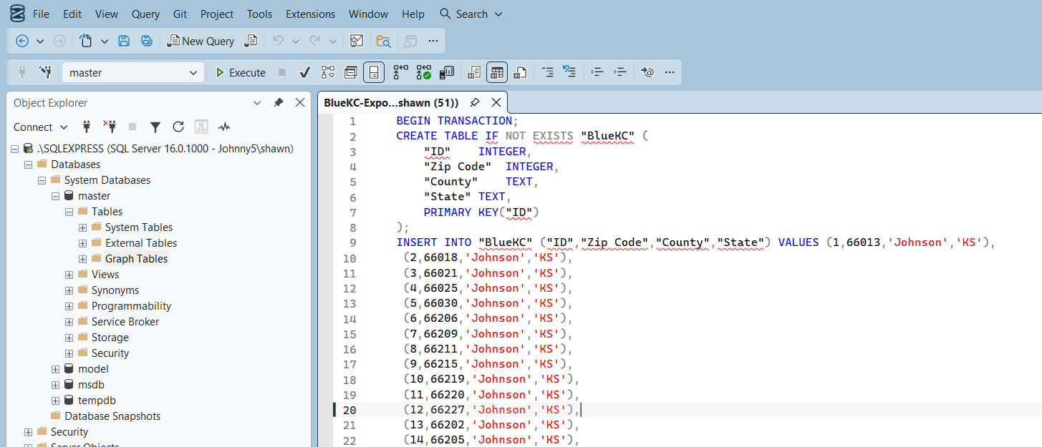

After executing the SQL script, I received an error message:
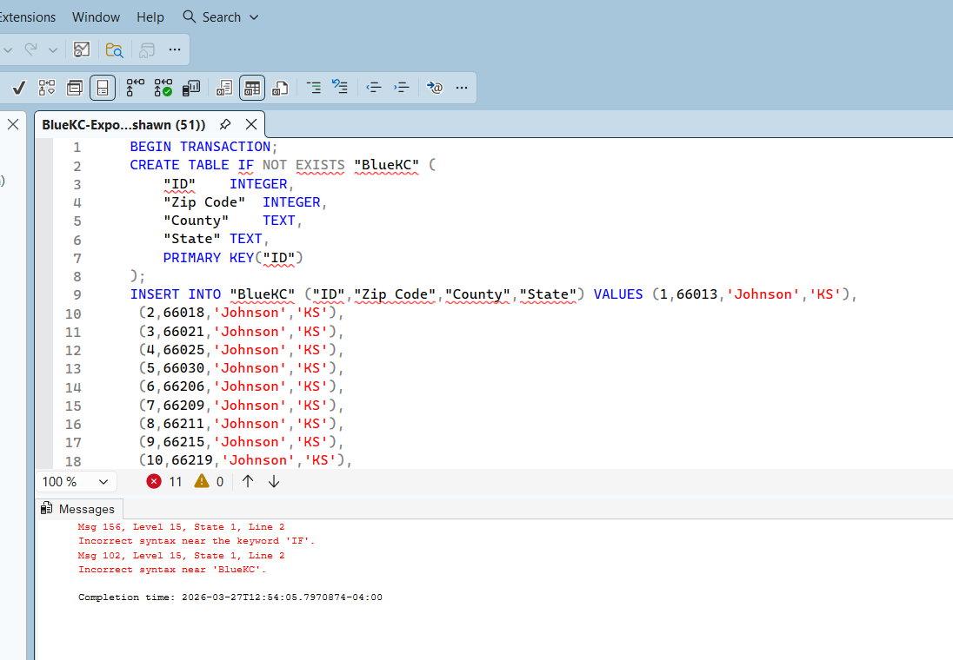

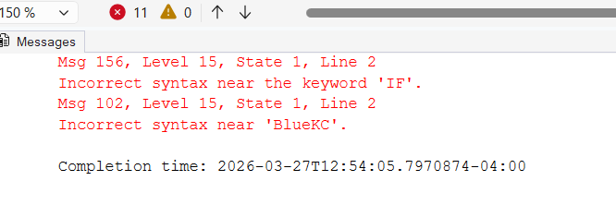
The lesson for this issue is to check the SQL structure. SQL Server does not use the syntax that SQLite uses. To verify this logic, I found a Stack Overflow discussion on this issue: CREATE TABLE IF NOT EXISTS equivalent in SQL Server
NOTE: Stack Overflow is a great resource for finding solutions to common issues. Even old threads on the system help. It helps because it provides context and history to understand WHY something doesn’t work. The original posting was about SQL Server 2008 R2, but it shows me this disconnect is a known issue.
For simplicity’s sake, I ran the following create code:
BEGIN TRANSACTION;
CREATE TABLE "BlueKC" (
"ID" INTEGER,
"Zip Code" INTEGER,
"County" TEXT,
"State" TEXT,
PRIMARY KEY ("ID")
);
INSERT INTO "BlueKC" ("ID","Zip Code","County","State") VALUES
(1,66013,'Johnson','KS'),
(2,66018,'Johnson','KS'),
(3,66021,'Johnson','KS'),
(4,66025,'Johnson','KS'),
(5,66030,'Johnson','KS'),
…
Running the updated code:
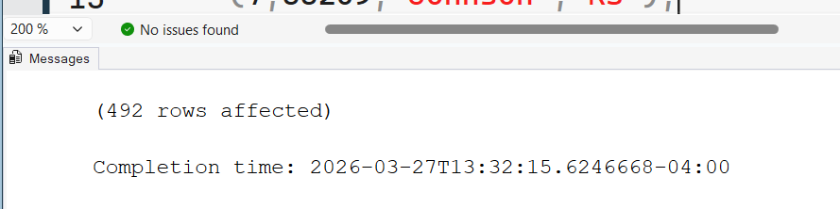

Looking at the sidebar to see the new table:
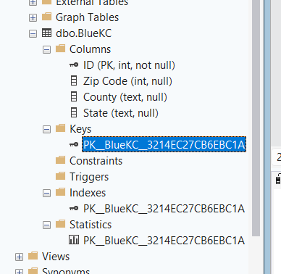
The table has been created with the parameters set up originally in SQLite.
To confirm the query fully worked, I will run my zip code test:
This is a simple query to find the county in which zip code 64012 is.
select County
from BlueKC
where “Zip Code” = 64012
64012 is the zip code for Belton, MO. Belton is within Cass County.
